Day 2
Exploring Graphs of Polar Curves

Today we will be investigating the characteristics of two basic forms of a polar curve. We will see how the parameters a, b, and n affect the shape of polar curves. Be prepared to make generalizations about the four types of curves.

We will be using the online graphing calculator www.desmos.com to help in our investigations.
Please watch the instructional video on our Googlesite to learn the basics of the program that you will need for this activity.

Let's explore two basic forms of a polar curve
r(θ) = a + b·cos(nθ)
r(θ) = a + b·sin(nθ)
Part 1 Exploring Circles

Use Desmos to graph the following polar curves:

1. r(θ) = 2 cos(θ)

2. r(θ) = 3 cos(θ)

3. r(θ) = -4 cos(θ)

4. r(θ) = -5 cos(θ)

5. What effects do the following parameters have on the parent function?
a:
b:
n:

6. What effect does the absolute value of b have on the graph?

7. What effect does the positive or negative value of b have on the graph?

Exploring Rose Polar Curves

1. Graph:
a. r(θ) = 4cos(θ)

b. r(θ) = 4cos(2θ)

c. r(θ) = 4cos(3θ)

d. r(θ) = 4cos(4θ)

2. What effects do the following parameters have on the parent function?
a:
b:
n:

3. We call each piece of a rose a leaf. How many leaves are produced for each equation?

a. 4cos(θ):

b. 4cos(2θ):

c. 4cos(3θ):

d. 4cos(4θ):

4. How does the value of n determine the number of leaves?

5. Graph:
a. r(θ) = 4cos(3θ)

b. r(θ) = 5cos(3θ)

c. r(θ) = 6cos(3θ)

6. What effect does the value of b have on the leaves of the rose?

7. Graph:

a. r(θ) = 5cos(3θ)

b. r(θ) = -5cos(3θ)

8. What effect does making the 5 negative have on the graph?

9. Compare and contrast the polar equations that produce circles and roses.

Exploring Limacon Curves

1. Graph:

a. r(θ) = 1 + 2cos(θ)

b. r(θ) = 2 + 4cos(θ)

c. r(θ) = 1 – 3cos(θ)

d. r(θ) = 2 – 5cos(θ)

2. What determines the following characteristics?
Inner loop:
Outer loop:

3. How do the absolute values of a and b effect the graph?

4. What effect does the positive or negative value of b have on the graph?

Exploring cardioid curves

1. Graph:

a. r = 2 + 2cosθ

b. r = 4 + 4cosθ

c. r = 5 + 5cosθ

2. What effects do the following parameters have on the parent function?
a:
b:
n:

3. How does the absolute value of a compare to the absolute value of b?

4. How do the absolute value of a and b affect the graph?

5. Graph:

a. r = 3 + 3cosθ

b. r = 3 – 3cosθ

6. What effect does the positive or negative value of b have on the graph?

What if…
1. We looked at these curves with sine instead of cosine?
Substitute sine in for cosine and explain what happens when we do this.

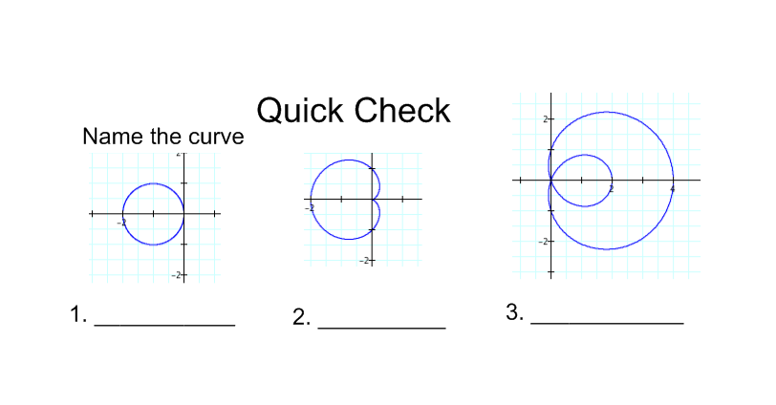
4. What effect does the sign of b have on the graphs of polar curves?

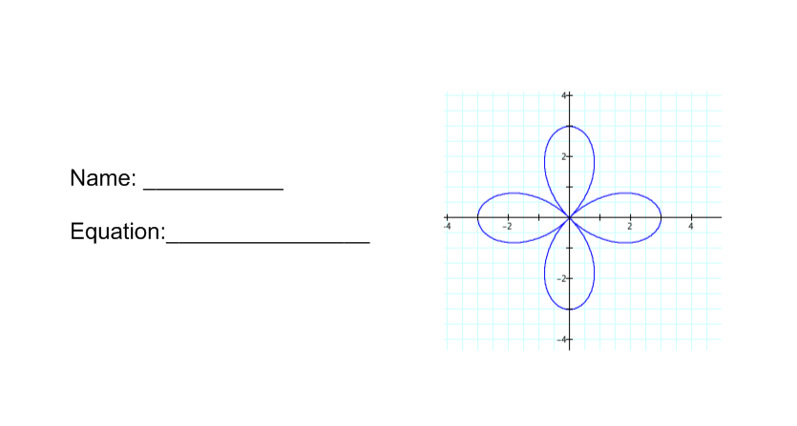
5. Name the curve shown below and write its equation.

Extension:
Below are all equations of limacon polar curves. Graph the following and describe each of the graphs. If there are differences, describe those and examine the equations in conjunction with the graphs. Create a conjecture that describes these differences.

$$r\left(θ\right)=1+3cos⁡(θ)$$
$$r\left(θ\right)=2-5cos⁡(θ)$$
$$r\left(θ\right)=4+cos⁡(θ)$$
$$r\left(θ\right)=5-2cos⁡(θ)$$
$$r\left(θ\right)=3+4cos⁡(θ)$$
$$r\left(θ\right)=5+7cos⁡(θ)$$
$$r\left(θ\right)=3+3cos⁡(θ)$$
Conjecture:

Can a limacon be a cardioid?

There are four major types of limacon curves.
1. Convex
2. Dimpled
3. Inner loop
4. Cardioid
The relationship between a and b determine which type it will be.
Make a generalization about the four common polar curves we investigated today.

